Preeti Sharma

JECRC University

17BCON415

246,Mahatma Ghandhi nagar,Ajmer road Jaipur, [preetidevsang@gmail.com](mailto:preetidevsang@gmail.com), 9782078532

B.tech-CSE

**Waste Water Management**

In the rural areas the problem of water management arises due :

* They don’t know the importance of water.
* Accessibility to improper drainage system.
* The collection of water at one place causes waterborne diseases.
* Improper storage of water.

Solutions :

* For a small-family 8-10 litre water in a day is enough to survive for drinking purposes.

So, waste water should be evaporated and the vapor should be cooled in order to use it for drinking purpose, which is described in detail in methodology with design part.

* Rainwater storage and management.
* Cost-effective method based on concept of evaporation.

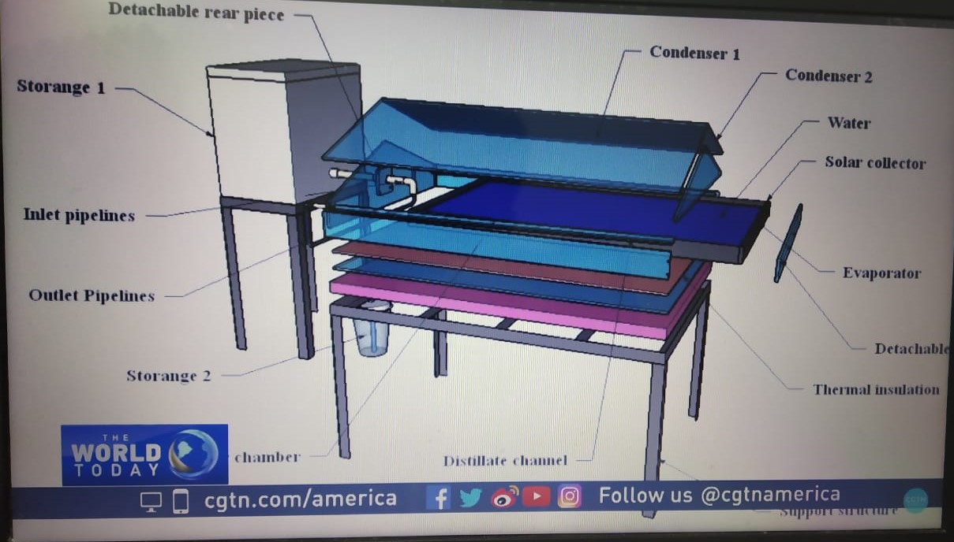

There must be a device on which we purify waste/pond water by applying some methodology and designing in a way which would be as follows:

* design

1. As shown in the above figure we take solar collector at to collect the waste/pond water which is applied with an evaporator at end of glass condenser attached at top.
2. The evaporated water from the glass condenser drop dip by dip along the sides .
3. And through the outlet pipe it gets stored in storage 1.
4. The purified water gets collected at storage 2.

* Methodology

This design is based on method

Evaporation is directly proportional to surface area

* Potential application/implementation

There must be a reservoir/pond to store rainwater or water coming from drainage in general evaporated and wasted. Reservoir will be helpful in maintaining groundwater layers, and water in that will be recycled to drinking water. There can also be culture in resource will open a source of income for people.

* Extension plan

Since, it is a cheap method we start the implementation from a rural area then gradually move towards implementing it in urban areas as well.

* This method helps to spread awareness in the society for the betterment of people.
* Helps to ensure the satisfaction of people by providing proper drainage system.
* This plan encourages rainwater storage and management efficiently.
* First target a village then we spread this plan to different villages.
* We transfer water from all the houses and deposit it in a tank and then produce a quantity of pure water.
* In general people use water in excess so this plan controls its wastage.